Insert your title here [Paper title style]

Author 1 [Author name style]
University A [Affiliation style]

Author 2 – blank line between authors with different affiliations [Author name style]
Department A [Affiliation style]
Author 3 [Author name style]
Department B [Affiliation style]
University B (authors with the same institutional affiliation can be grouped this way) [Affiliation style]

Author 4 and Author 5 – authors with the same affiliation can be grouped this way [Author name style]
Department C [Affiliation style]
University C [Affiliation style]

Place your abstract here ... no more than 150 words … [Abstract and keywords style]

Keywords: One line of key or focus terms by which your paper can be indexed. [Abstract and keywords style]

First level heading [First level heading style]

Body of your paper … use Times New Roman 10 point, left aligned, single spaced. Blank lines before and after headings and paragraphs are to be sized the same as text lines, i.e., 10 point (Times NR).

For paragraphing, use a single blank line between each paragraph, and no indents. Do not use Spacing Before or Spacing After your paragraphs. [Paper body style]

Second level heading [Second level heading style]

Put a blank line before and after the second level heading. [Paper body style]

Third level heading [Third level heading style]
Do not include a blank line after a third level heading. Use bulleted or numbered lists in preference to third level headings where possible. [Paper body style]

[This is a quotation] Use Times New Roman 10 point, left aligned, single spaced, indented 1.0 cm left and right, not italicised, without quote marks, one blank line before and after. Indents may be varied slightly from 1.0 cm to improve the fit. Referencing for the quotation may be given in the running text immediately before the quotation, or may be appended to the end of the quotation. In general, very short quotations using only a few words should be given with quote marks in your running text, whilst only longer quotations using a line or more should be formatted as quotations. (reference) [Quotation style]

This is a bulleted list:

• Times New Roman 10 point
• left aligned, single spaced
• no indents except a hanging indent 0.5 cm. [Bulleted List style]

This is an ordered list:

- Times New Roman 10 point
- left aligned, single spaced
- no indents except a hanging indent 0.5 cm. Indentation may be varied slightly to improve the fit.
- select only from these kinds of ordering: 1., 2., …; i., ii., …; a., b., … Do not use any other kind. [Ordered list style]

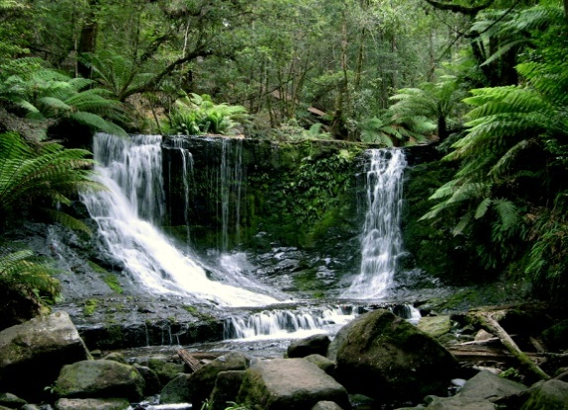

Figure 1: Sample of a figure (legend is below figure) [Figure style]

Figures must be placed in their correct location in your running text. All figures should be included in your Word file, and not in separate graphic or drawing package format. Labeling should be consistent with the fonts used in the text of your paper, i.e., Times New Roman. Number sequentially, Figure 1, Figure 2, etc. Do not use variations such as Figure 1a, 1b.

Table 1: A sample table (title is above table, centred, bold) [Table title style]

Location [Paper Body style] | Tables must be placed in their correct, appropriate locations in your running text [Paper Body style]
General | In general use Times New Roman 10 point and other body text specifications for all text within a table and its title, though 9 point may be used as required for narrow columns. Tables should have a title with consecutive numbering (e.g.: Table 1: Title of the table), bolded, using sentence case, centred, and located at the top of the table. For headings within tables use sentence case, with bold and centering optional.
Format | Centre each table and select appropriate widths for the table and for each column, using percentages. Use of borders for all cells ('All', with style '1/4 point') is recommended, mainly because borders seem to be helpful for on screen reading. In columns of numbers, use centre or decimal point alignment.
Explanatory text | If your table requires explanatory text that is inappropriate for placing in your running text, place it at the bottom of the table, formatted to the same width as the table.
Other features | Cell background colouring or shading may be used, but check that grey scale printing (600 dpi) is not impaired, and note that when a web version file is created, the Proceedings editors may use a standard background colour for the first row or other elements of a table.
References [First level heading style]

Use APA 6th edition style for references. This style prescribes alphabetical order by first author. Use Times New Roman 10 point, left aligned, hanging indent 0.5 cm, with no blank lines.

For online publications: if the online book/article has a Digital Object Identifier (DOI), please insert the DOI. If not, please give the URL of the online book/article, journal homepage, or database homepage. Please do not insert URLs for publications that only offer pay per view, institutional subscriber, or on campus only access to full text. Please also omit the date of retrieval.

The following list provides examples of referencing for the main kinds of publications:

Baharun, N., & Porter, A. (2009). Teaching statistics using a blended approach: Integrating technology-based resources. In R. J. Atkinson, & C. McBeath (Eds), Same places, different spaces. Proceedings ascilite Auckland 2009 (pp. 40-48). Retrieved from http://www.ascilite.org.au/conferences/auckland09/procs/baharun.pdf
Bradley, D. (2008). Review of Australian higher education: Final report. Retrieved from http://www.innovation.gov.au/HigherEducation/Documents/Review/PDF/Higher%20Education%20Review_one%20document_02.pdf
Eccles, J. S., Adler, T. F., Futterman, R., Goff, S. B., Kaczala, C. M., Meece, J. L., & Midgley, C. (1983). Expectancies, values, and academic behaviors. In J. T. Spence (Ed.), Achievement and achievement motivation (pp. 75-146). San Francisco, CA: W. H. Freeman.
Garrison, R., & Vaughan, H. (2008). Blended learning in higher education: Framework, principles and guidelines. San Francisco, CA: Jossey-Bass.
Gedik, N., Kiraz, E., & Ozden, Y. (2013). Design of a blended learning environment: Considerations and implementation issues. Australasian Journal of Educational Technology, 29(1), 1-19. Retrieved from http://ascilite.org.au/ajet/submission/index.php/AJET/article/view/6/21
Huang, E. Y., Lin, S. W., & Huang, T. K. (2011). What type of learning style leads to online participation in the mixed-mode e-learning environment? A study of software usage instruction. Computers & Education, 58(1), 338-349. doi:10.1016/j.compedu.2011.08.003
Mollison, M. (2010). Producing videos: A complete guide [EBL version]. Retrieved from
http://www.aut.eblib.com.au
Pajares, F. (2002). Overview of social cognitive theory and of self-efficacy. Retrieved from http://p20motivationlab.org/social-cognitive-theory

[References style is used for all the above references]

Contact author: Author full name, author@email.com [contact details style]

Please cite as: Note: ascilite organisers will populate this citation space for you – please leave blank.

ascilite organisers will append a copyright notice here.

